Annexure XI
VGF Process Flow

VGF Process

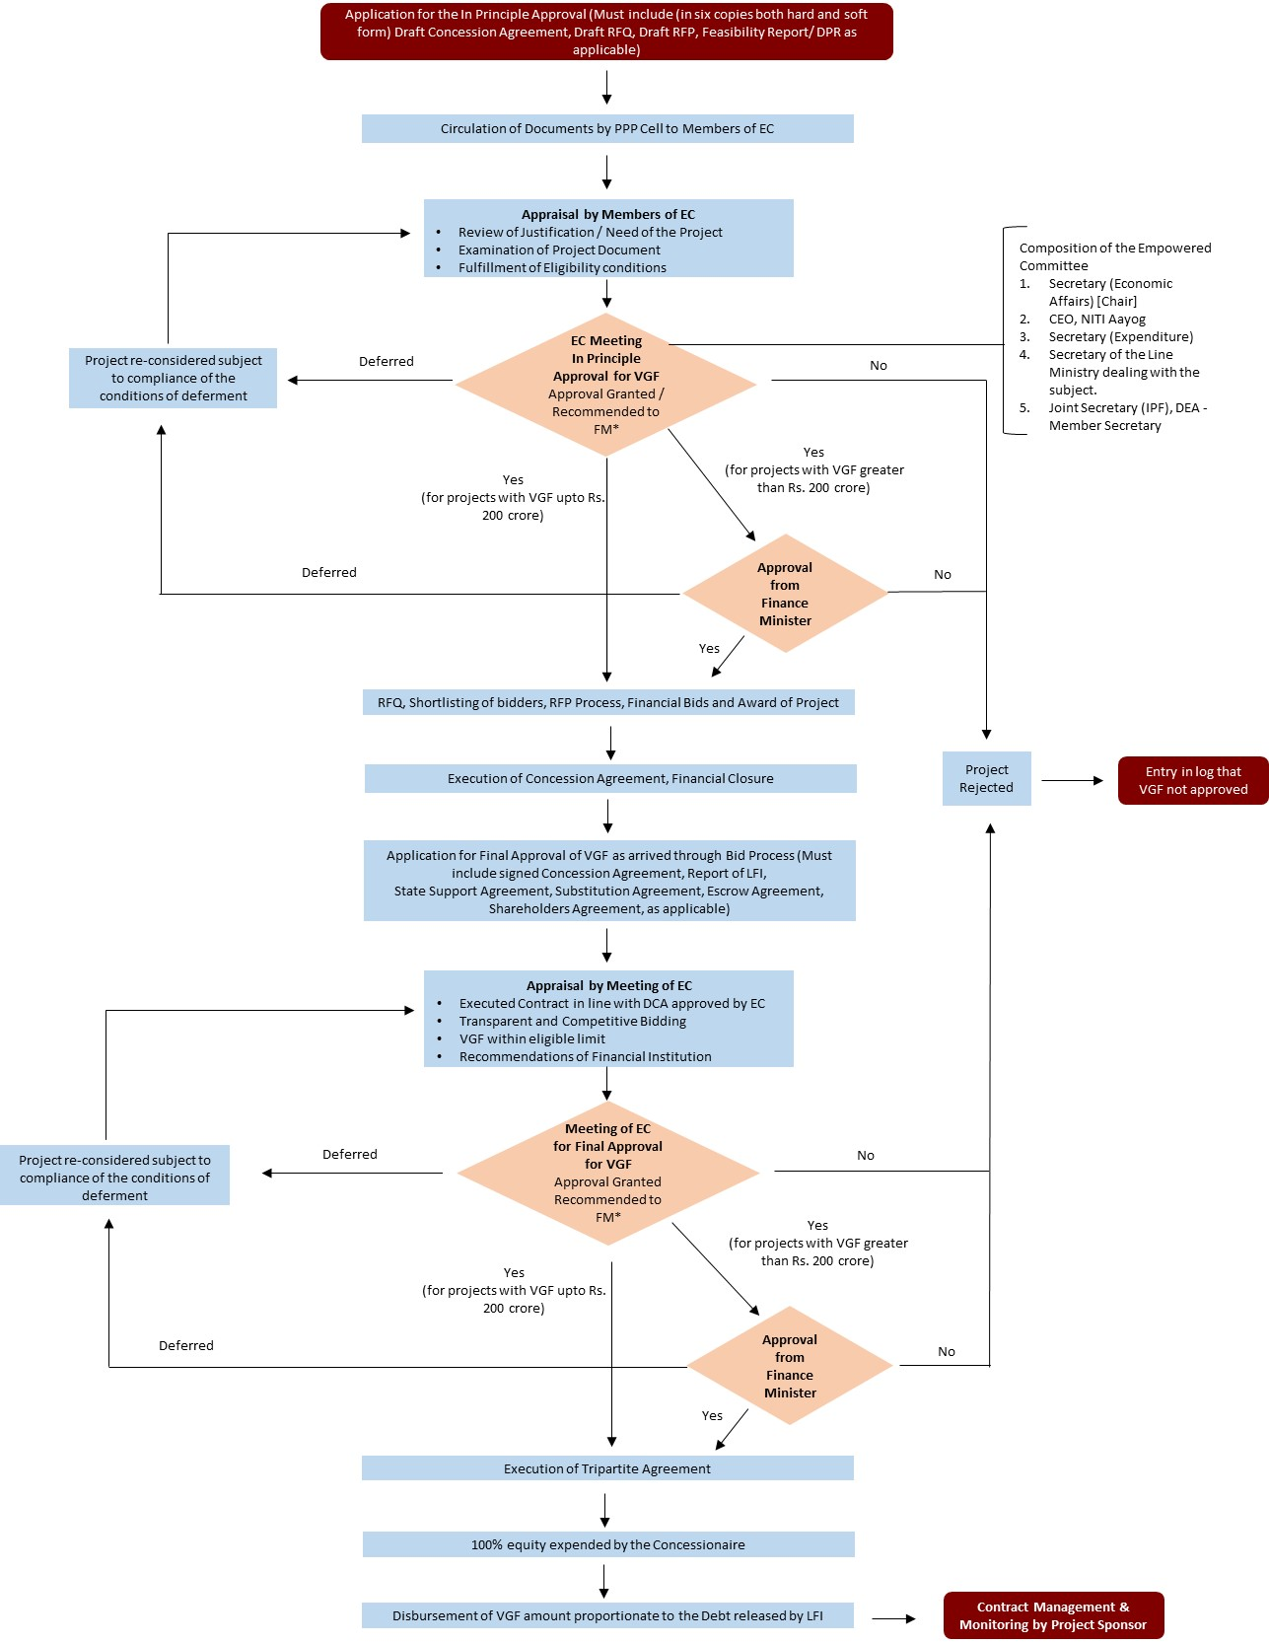

*Only projects where VGF sought is greater than Rs. 200 crores will be recommended to the Finance Minister for approval.

